LOGIN

HTML:-

<html>

<head>

<title>Expedition</title> <link rel="stylesheet" type="text/css"

href="login.css"> <body> <div class="loginbox"> <img src="avatar.png"

class="avatar"> <h1>Login Here</h1> <form action="login.php" method="post">

<p>Username</p> <input type="text" name="user" required placeholder="Enter

Username"> <p>Password</p> <input type="password" name="password" required

placeholder="Enter Password"> <input type="submit" name="" value="Login"> <br> <a href="Sign.html">Don't have an

account?</a> </form>

</div>

</body>

</head>

</html>

CSS CODE:-

html, body {

margin: 0;

padding: 0;

width: 100%;

height: 100%;

font-family: Poppins !important;

}

body{

margin: 0;

padding: 0;

background: url(unsplash01.jpg);

background-size: cover;

background-repeat: no-repeat;

background-position: center;

font-family: sans-serif;

}

.loginbox{

width: 320px;

height: 420px;

background: #000;

color: #fff;

top: 50%;

left: 50%;

position: absolute;

transform: translate(-50%,-50%);

box-sizing: border-box;

padding: 70px 30px;

background: linear-gradient(to bottom, #00ffcc,#ccccff);

border-radius: 10px;

}

.avatar{

width: 100px;

height: 100px;

border-radius: 50%;

position: absolute;

top: -50px;

left: calc(50% - 50px);

}

h1{

margin: 0;

padding: 0 0 20px;

text-align: center;

font-size: 22px;

}

.loginbox p{

margin: 0;

padding: 0;

font-weight: bold;

}

.loginbox input{

width: 100%;

margin-bottom: 20px;

}

.loginbox input[type="text"], input[type="password"]

{

border: none;

border-bottom: 1px solid #fff;

background: transparent;

outline: none;

height: 40px;

color: #fff;

font-size: 16px;

}

.loginbox input[type="submit"]

{

border: none;

outline: none;

height: 40px;

background: #fb2525;

color: #fff;

font-size: 18px;

border-radius: 20px;

}

.loginbox input[type="submit"]:hover

{

cursor: pointer;

background: #ffc107;

color: #000;

}

.loginbox a{

text-decoration: none;

font-size: 12px;

line-height: 20px;

color: darkgrey;

}

.loginbox a:hover

{

color: #ffc107;

}

PHP CODE:-

<?php

$con=mysqli_connect("localhost","root","");

$sel=mysqli_select_db($con,"pavan");

$a=$_POST["user"];

$b=$_POST["password"];

$stu="select * from login";

$row =mysqli_query($con,$stu);

while($r=mysqli_fetch_array($row))

{

//echo $r['login']."<br>".$r['password']."<br>".$r['sno'];

if($a==$r['login'] and $b==$r['password'])

{

echo"Hello $a";

$set=1;

header('Location:http://localhost/after/afterlogin.php');

break;

}}

if($set==0)

{

echo "Invalid Login";

header('Location:http://localhost/after/login.html');

}

?>

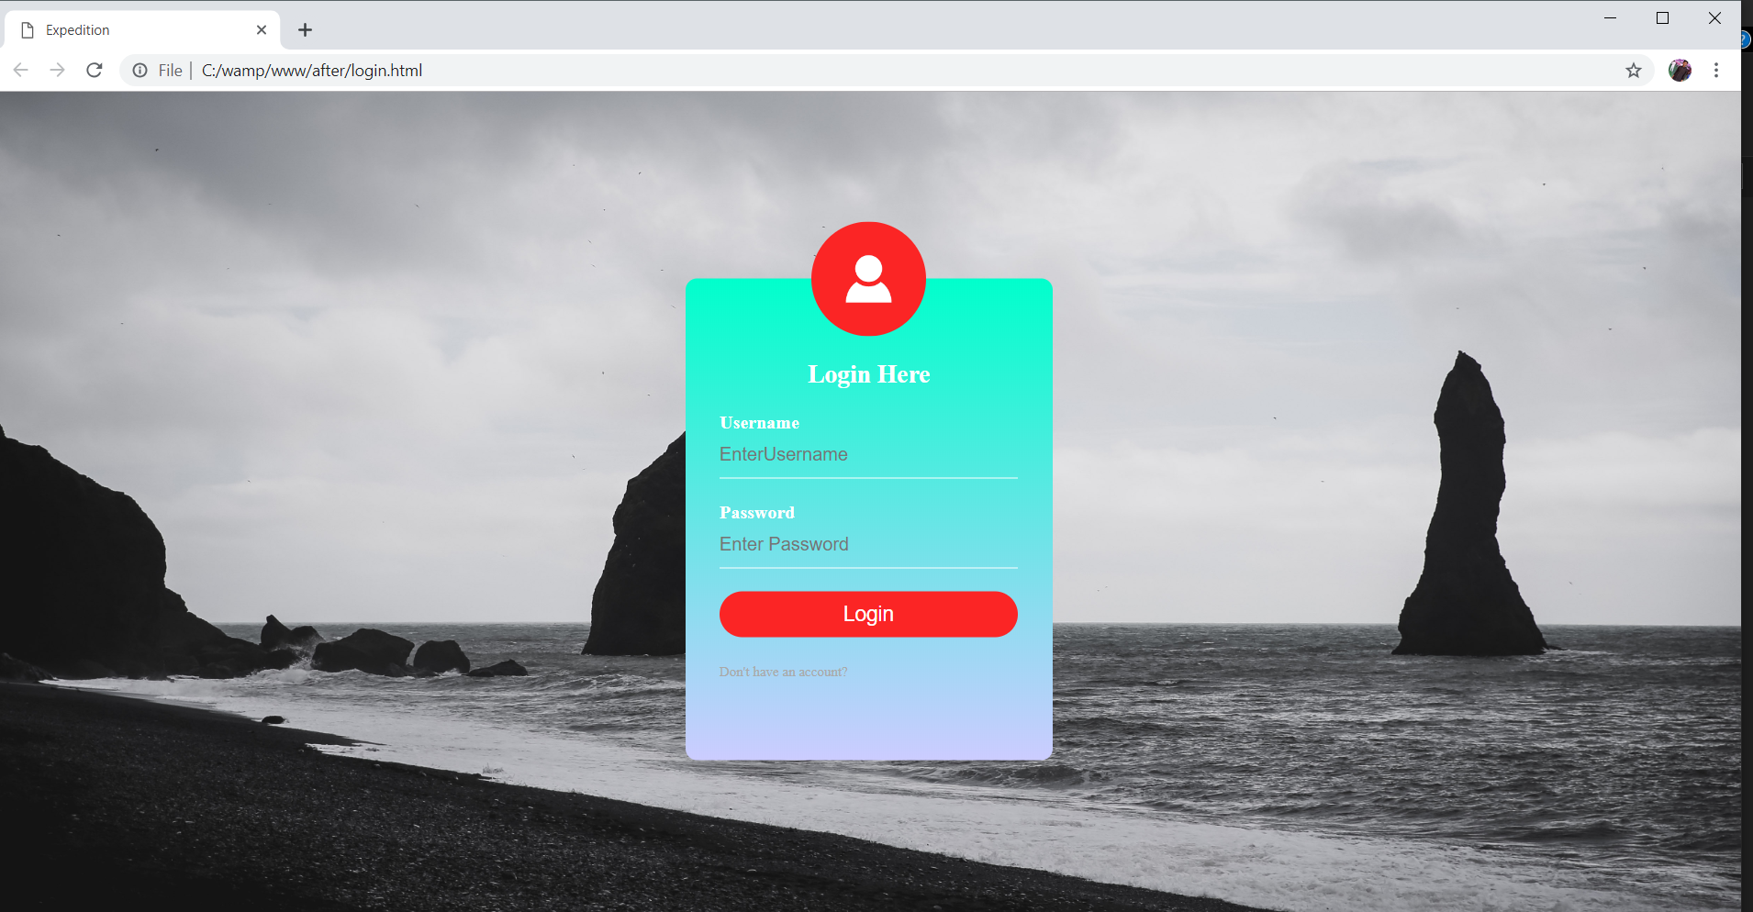

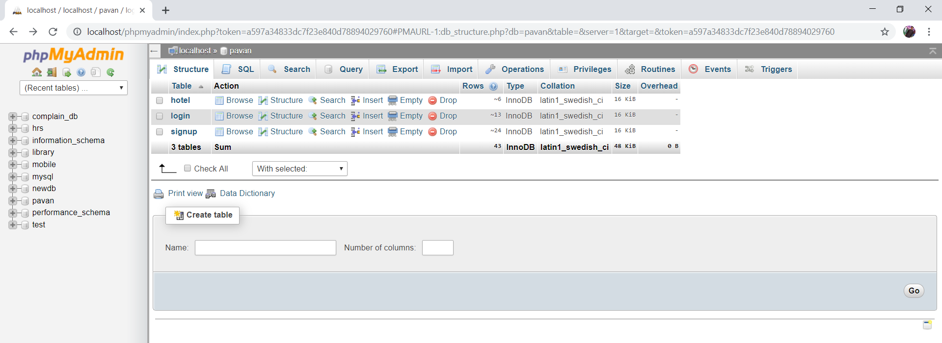

SIGNUP PAGE

HTML CODE:-

<html>

<head>

<title>Expedition

</title>

<script type="text/javascript">

var check = function() {

if (document.getElementById('password').value ==

document.getElementById('confirm_password').value) {

document.getElementById('message').style.color = 'green';

document.getElementById('message').innerHTML = '&#10004';

} else {

document.getElementById('message').style.color= 'red';

document.getElementById('message').innerHTML = '&#10006';

}

}

</script>

<link rel="stylesheet" type="text/css" href="style.css">

</head>

<body background="unsplash01.jpg">

<H1>Please Fill The Form To Create an account</H1>

<div style="width: 390px;

height: 590px;

color: #fff;

top: 50%;

left: 50%;

position: absolute;

transform: translate(-50%,-50%);

box-sizing: border-box;

padding: 70px 30px;

background: linear-gradient(to bottom, #00ffcc,#ccccff);

border-radius: 10px;">

<form action="signup.php" method="get">

<center><img src="avatar.png" style="width: 100px;

height: 100px;

border-radius: 50%;

position: absolute;

top: -50px;

left: calc(50% - 50px);"></center>

<table width="50%">

<tr>

<td></td>

</tr>

<tr>

<td>Firstname</td>

<td><input type="text" id= "fname" name="fname" placeholder="Firstname" class="loginbox" style="border: none;

border-bottom: 1px solid #fff;

background: transparent;

outline: none;

height: 40px;

color: #fff;

font-size: 16px;" required></td>

</tr>

<tr>

<td>Lastname</td>

<td><input type="text" name="lname" id= "lname" placeholder=" Lastname" class="loginbox" style="border: none;

border-bottom: 1px solid #fff;

background: transparent;

outline: none;

height: 40px;

color: #fff;

font-size: 16px;"required value=""></td>

</tr>

<tr>

<td>Email</td>

<td><input type="Email" name="email" id="email" required placeholder="Enter Email" class="loginbox"></td>

</tr>

<tr>

<td>Password</td>

<td><input type="Password" name="pass" id="password" placeholder="Enter Password" class="loginbox" onkeyup="check();" required></td>

</tr>

<tr>

<td>Confirm Password</td>

<td><input type="Password" name="pass1" id="confirm_password" placeholder="Confirm Password" onkeyup="check();" class="loginbox" required></td>

<span id="message"></span>

</tr>

<tr>

<td >Sex</td>

<td>

<select name="Sex" style="background: transparent; outline: none; height: 40px;" required>

<option value="Male">Male</option>

<option value="Female">Female</option>

</select>

</td>

</tr>

<tr>

<td>

PhoneNumber

</td>

<td><input type="number" id="phone" name="Phone" placeholder="Enter PhoneNumber" required></td>

</tr>

<tr>

<td>Date of Birth</td>

<td><input type="Date" id="dob" name="dob" required></td>

</tr>

<tr>

<td><input type="checkbox" name="che" required>Remember me</td>

</tr>

<tr>

<td><input type="submit" name="submit" class="loginbox" required style="cursor: pointer;

border: none;

outline: none;

height: 40px;

width: 120px;

color: #fff;

font-size: 18px;

border-radius: 20px;

color: #000;" value="submit"></td>

</tr>

</table>

</form>

</div>

</body>

</html>

PHP CODE:-

<?php

$con=mysqli_connect("localhost","root","");

$sel=mysqli_select_db($con,"pavan");

$a=$_GET["fname"];

$b=$_GET["lname"];

$c=$_GET["email"];

$d=$_GET["pass"];

$e=$_GET["pass1"];

$f=$_GET["Sex"];

$g=$_GET["Phone"];

$h=$_GET["dob"];

$que="insert into signup (fname,lname,email,pass,pass1,sex,phone,dob)values('$a','$b','$c','$d','$e','$f',$g,'$h')";

if(mysqli_query($con,$que))

{

echo "records Inserted Succesfully";

}

else

{

echo "error";

}

$que1="insert into login(login,password)values('$a','$d')";

if(mysqli_query($con,$que1))

{

echo "Records Inserted Succesfully";

header('Location:http://localhost/after/login.html');

}

else

{

echo "Error";

}

?>

CSS CODE:-

body{

margin: 0;

padding: 0;

background-repeat: repeat-x;

background-size: cover;

ba

background-position: center;

font-family: sans-serif;

}

.avatar{

width: 100px;

height: 100px;

border-radius: 50%;

position: absolute;

top: -50px;

left: calc(50% - 50px);

}

h1{

margin: 0;

padding: 0 0 20px;

text-align: center;

font-size: 22px;

}

.loginbox p{

margin: 0;

padding: 0;

font-weight: bold;

}

.loginbox input{

width: 100%;

margin-bottom: 20px;

}

.loginbox input[type="text"], input[type="password"],input[type="number"],input[type="email"],input[type="date"]

{

border: none;

border-bottom: 1px solid #fff;

background: transparent;

outline: none;

height: 40px;

color: #fff;

font-size: 16px;

}

.loginbox input[type="submit"]

{

border: none;

outline: none;

height: 40px;

background: #fb2525;

color: #fff;

font-size: 18px;

border-radius: 20px;

cursor: pointer;

}

.loginbox input[type="submit"]:hover

{

cursor: pointer;

background: #ffc107;

color: #000;

}

.loginbox a{

text-decoration: none;

font-size: 12px;

line-height: 20px;

color: darkgrey;

}

.loginbox a:hover

{

color: #ffc107;

}

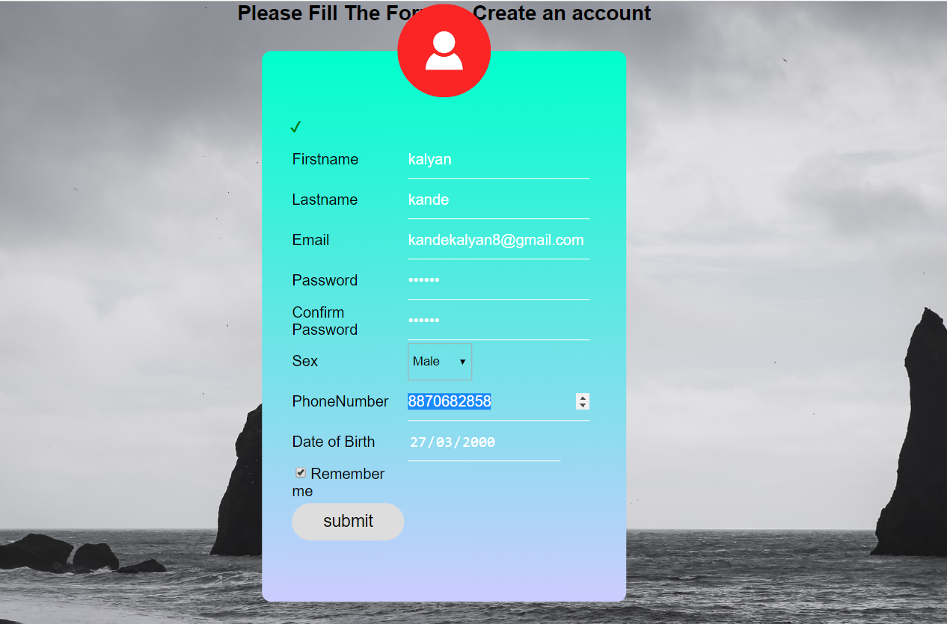

AFTER LOGIN PHP CODE:-

<!DOCTYPE html>

<html>

<head>

<meta name="viewport" content="width=device-width, initial-scale=1">

<style>

* {box-sizing: border-box;}

body {font-family: Verdana, sans-serif;}

.mySlides {display: none;}

img {vertical-align: middle;}

/* Slideshow container */

.slideshow-container {

height: 50px;

width: 720px;

position: relative;

margin: auto;

border-radius: 10px;

}

/* Caption text */

.text {

color: #f2f2f2;

font-size: 15px;

padding: 8px 12px;

position: absolute;

bottom: 8px;

width: 100%;

text-align: center;

}

.sep

{

color: #f2f2f2;

font-size: 15px;

//position: absolute;

bottom: 28px;

left: 16px;

}

/* Number text (1/3 etc) */

.numbertext {

color: #f2f2f2;

font-size: 12px;

padding: 8px 12px;

position: absolute;

top: 0;

}

/* The dots/bullets/indicators */

.dot {

height: 15px;

width: 15px;

margin: 0 2px;

background-color: #bbb;

border-radius: 50%;

display: inline-block;

transition: background-color 0.6s ease;

}

.active {

background-color: #717171;

}

/* Fading animation */

.fade {

-webkit-animation-name: fade;

-webkit-animation-duration: 1.5s;

animation-name: fade;

animation-duration: 1.5s;

}

@-webkit-keyframes fade {

from {opacity: .4}

to {opacity: 1}

}

@keyframes fade {

from {opacity: .4}

to {opacity: 1}

}

/* On smaller screens, decrease text size */

@media only screen and (max-width: 300px) {

.text {font-size: 11px}

}

</style>

<title>Expedition</title>

<link rel="stylesheet" type="text/css" href="style1.css">

<link rel="stylesheet" href="https://use.fontawesome.com/releases/v5.8.1/css/all.css" integrity="sha384-50oBUHEmvpQ+1lW4y57PTFmhCaXp0ML5d60M1M7uH2+nqUivzIebhndOJK28anvf" crossorigin="anonymous">

<script type="text/javascript">

<script>

(function() {

var cx = '009240432252087345302:rhqeg_clwwq';

var gcse = document.createElement('script');

gcse.type = 'text/javascript';

gcse.async = true;

gcse.src = 'https://cse.google.com/cse.js?cx=' + cx;

var s = document.getElementsByTagName('script')[0];

s.parentNode.insertBefore(gcse, s);

})();

</script>

<gcse:search></gcse:search>

<gcse:search></gcse:search>

</script>

</head>

<body >

<div class="nav">

<ul>

<li><input type="text" name="" onclick="function()"><i class="fas fa-search"></i></li>

<li><input type="button" value="Home" class="button"></li>

<li><a href="1.html"><input type="button" value="Train Timings" class="button"></a></li>

<li><a href="hotels.html"><input type="button" value="Hotels" class="button"></a></li>

<li><a href="maps.html"><input type="button" name="button" class="button" value="Explore"></a></li>

<li><a href="login.html"><i class="fas fa-sign-out-alt"></i></a>

</ul>

</div><br><br><br><br><br>

<div class="slideshow-container">

<div class="mySlides fade">

<div class="numbertext">1 / 3</div>

<img src="img1.jpg" style="width:100%">

<div class="text">Incredible India</div>

<div clss="sep" >

<a href="https://www.incredibleindia.org/content/incredibleindia/en/destinations.html">

<input style="background: white" type="button" class="button" value="Explore Now" >

</a>

</div>

</div>

<div class="mySlides fade">

<div class="numbertext">2 / 3</div>

<img src="img2.jpg" style="width:100%">

<div class="text">Japan Tourism</div>

<div clss="sep"> <a href="https://www.japan.travel/en/"><input style="background: white" type="button" class="button" value="Explore Now"></a></div>

</div>

<div class="mySlides fade">

<div class="numbertext">3 / 3</div>

<img src="img3.jpg" style="width:100%">

<div class="text">Newyork Tourist</div>

<div clss="sep"><a href="https://www.nyc.com/visitor_guide/"> <input style="background: white" type="button" class="button" value="Explore Now"></a></div>

</div>

</div>

<br>

<div style="text-align:center">

<span class="dot"></span>

<span class="dot"></span>

<span class="dot"></span>

</div>

<script>

var slideIndex = 0;

showSlides();

function showSlides() {

var i;

var slides = document.getElementsByClassName("mySlides");

var dots = document.getElementsByClassName("dot");

for (i = 0; i < slides.length; i++) {

slides[i].style.display = "none";

}

slideIndex++;

if (slideIndex > slides.length) {slideIndex = 1}

for (i = 0; i < dots.length; i++) {

dots[i].className = dots[i].className.replace(" active", "");

}

slides[slideIndex-1].style.display = "block";

dots[slideIndex-1].className += " active";

setTimeout(showSlides, 2000); // Change image every 2 seconds

}

</script>

<div class="social-media">

<ul>

<li><a href="https://www.facebook.com/pavanpk.20"><i class="fab fa-facebook-f"></i></a></li>

<li><a href="https://www.instagram.com/pavan__karthik/"><i class="fab fa-instagram"></i></a></li>

<li><a href="https://twitter.com/PAVANKA40606119"><i class="fab fa-twitter"></i></a></li>

</ul>

</div>

<div class="side-strip">

<span>ADVENTURE FILL SOULS</span>

</div>

</body>

</html>

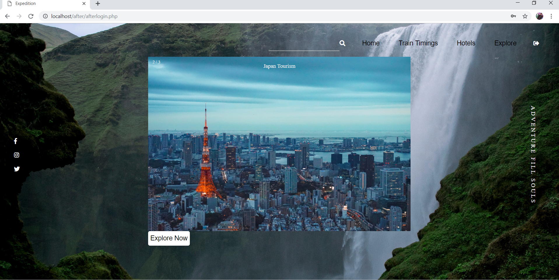HOTEL BOOKING:-

HTML CODE:-

<!DOCTYPE html>

<html>

<style type="text/css">

</style>

<head>

<link rel="stylesheet" href="https://use.fontawesome.com/releases/v5.8.1/css/all.css" integrity="sha384-50oBUHEmvpQ+1lW4y57PTFmhCaXp0ML5d60M1M7uH2+nqUivzIebhndOJK28anvf" crossorigin="anonymous">

<link type="text/css" rel="stylesheet" href="hotel.css" />

<meta name="viewport" content="width=device-width, initial-scale=1">

<title></title>

</head>

<body style="background:url(bk.jpg) no-repeat ;background-size: cover;">

<div class="b">

<div id="booking" class="section">

<div class="section-center">

<div class="container">

<div class="booking-form">

<form action="action1.php" method="GET">

<div class="form-group">

<span class="form-label">Your Destination</span>

<input class="form-control" type="text" name="des" placeholder="Enter a destination or hotel name" style="width: 220px;opacity: 0.79">

</div>

<div class="row">

<div class="col-sm-6">

<div class="form-group">

<span class="form-label">Check In</span>

<input class="form-control" type="date" name="chei" required style="opacity: 0.79">

</div>

</div>

<div class="col-sm-6">

<div class="form-group">

<span class="form-label">Check out</span>

<input class="form-control" type="date" name="cheo" required style="opacity: 0.79">

</div>

</div>

</div>

<div class="row">

<div class="col-sm-4">

<div class="form-group">

<span class="form-label">Rooms</span>

<select class="form-control" name="room" style="width: 50px;opacity: 0.79" >

<option value="1">1</option>

<option value="2">2</option>

<option value="3">3</option>

</select>

<span class="select-arrow"></span>

</div>

</div>

<div class="col-sm-4">

<div class="form-group">

<span class="form-label">Adults</span>

<select class="form-control" name="adu" style="width: 50px;opacity: 0.79">

<option value="1">1</option>

<option value="2">2</option>

<option value="3">3</option>

</select>

<span class="select-arrow"></span>

</div>

</div>

<div class="col-sm-4">

<div class="form-group">

<span class="form-label">Childrens</span>

<select class="form-control" name="chi" style="width: 50px;opacity: 0.79">

<option value="0">0</option>

<option value="1">1</option>

<option value="2">2</option>

</select>

<span class="select-arrow"></span>

</div>

</div>

</div>

<div class="button" align="center"><br>

<input type="Submit" class="button1" name="" value="Submit">

</div>

</form>

</div>

</div>

</div>

</div>

</div>

</div>

<div class="ka">

<ul>

<li>

<img style="padding-left: 40px;padding-right: 40px;padding-top: 12px ;display: inline-block;background-color: #4d9900" src="https://img.icons8.com/metro/25/000000/airport.png">

</li>

<li><img style="padding-left: 40px;padding-right: 40px;display: inline-block;background-color: #4d9900" src="https://img.icons8.com/ios/25/000000/5-star-hotel-filled.png"></li>

<li><img style="padding-left: 40px;padding-right: 40px;display: inline-block;background-color: #4d9900" src="https://img.icons8.com/ios/27/000000/sunbathe-filled.png"></li>

<li><img style="padding-left: 40px;padding-right: 40px;display: inline-block;background-color: #4d9900" src="https://img.icons8.com/ios/27/000000/train-filled.png"></li>

</ul>

</div>

</body>

</html>

CSS CODE:-

.b{

width: 950px;

border: 5px solid black;

padding: 25px;

margin: auto;

height: 410px;

position: absolute;

top:-90px;

bottom: 0px;

left: 0px;

right:0px;

border-radius: 10px;

padding-bottom: 30px;

}

.ka{

width: 450px;

border: 5px solid black;

padding: 0.5px;

margin: auto;

height: 50px;

position: absolute;

top:-550px;

bottom: 0px;

left: 0px;

right:0px;

border-radius: 10px;

background-color: #4d9900;

}

.ka li

{

display: inline;

list-style-type: none;

padding: 9px 0px;

}

img {

transition: transform .2s; /* Animation */

margin: 0 auto;

}

img:hover{

transform: scale(1.5);

}

.ka ul

{

display: inline;

align-items: stretch; /* Default */

justify-content: space-between;

width: 100%;

background: #fafafa;

margin: 0;

padding: 0;

}

.booking-form.form-label{

display: inline-block;

}

.booking-form {

padding: 30px 350px;

-webkit-box-shadow: 0px 5px 20px -5px rgba(0, 0, 0, 0.3);

box-shadow: 0px 5px 20px -5px rgba(0, 0, 0, 0.3);

border-radius: 4px;

}

.booking-form .form-group {

position:relative;

margin-bottom: 03px;

display: inline-block;

}

.booking-form .form-control {

background-color: #ebecee;

border-radius: 4px;

border: none;

height: 40px;

-webkit-box-shadow: none;

box-shadow: none;

color: #3e485c;

font-size: 14px;

}

.booking-form .form-control::-webkit-input-placeholder {

color: rgba(62, 72, 92, 0.3);

}

.booking-form .form-control:-ms-input-placeholder {

color: rgba(62, 72, 92, 0.3);

}

.booking-form .form-control::placeholder {

color: rgba(62, 72, 92, 0.3);

}

.booking-form input[type="date"].form-control:invalid {

color: rgba(62, 72, 92, 0.3);

}

.booking-form select.form-control {

-webkit-appearance: none;

-moz-appearance: none;

appearance: none;

}

.booking-form select.form-control+.select-arrow {

position: absolute;

right: 0px;

bottom: 4px;

width: 32px;

line-height: 32px;

height: 32px;

text-align: center;

pointer-events: none;

color: rgba(62, 72, 92, 0.3);

font-size: 14px;

}

.booking-form select.form-control+.select-arrow:after {

content: '\279C';

display: block;

-webkit-transform: rotate(90deg);

transform: rotate(90deg);

}

.booking-form .form-label {

display: inline-block;

color: #3e485c;

font-weight: 700;

margin-bottom: 6px;

margin-left: 7px;

}

.booking-form .submit-btn {

display: inline-block;

color: #fff;

background-color: #1e62d8;

font-weight: 700;

padding: 14px 30px;

border-radius: 4px;

border: none;

-webkit-transition: 0.2s all;

transition: 0.2s all;

}

.booking-form .submit-btn:hover,

.booking-form .submit-btn:focus {

opacity: 0.9;

}

.section {

position: relative;

height: 100vh;

}

.section .section-center {

position: absolute;

top:30%;

left: 0;

right: 0;

-webkit-transform: translateY(-50%);

transform: translateY(-50%);

}

#booking {

font-family: 'Montserrat', sans-serif;

background-size: cover;

background-position: center;

}

#booking::before {

content: '';

position: absolute;

left: 0;

right: 0;

bottom: 0;

top: 0;

}

input[type="submit"] {

border:2px solid green;

padding:5px 20px;

font-size:30px;

background:linear-gradient(#4d9900 ,green) center/100% 0px no-repeat;

transition:0.5s all linear;

}

input[type="submit"]:hover {

background-size:100% 100%;

}

PHP CODE (DATA BASE):-

<?php

$servername = "localhost";

$username = "root";

$password = "";

$dbname = "pavan";

$des = $_GET["des"];

$chei = $_GET['chei'];

$cheo= ($_GET['cheo']);

$room=($_GET['room']);

$adu=($_GET['adu']);

$chi=($_GET['chi']);

echo $chei;

// Create connection

$conn = new mysqli($servername, $username, $password, $dbname);

// Check connection

if ($conn->connect_error) {

die("Connection failed: " . $conn->connect_error);

}

$sql = "INSERT INTO hotel (Hotel,Check_in,Check_out,Rooms,Adults,Children)

VALUES ('$des', '$chei', '$cheo','$room','$adu','$chi')";

if ($conn->query($sql) === TRUE) {

echo "New record created successfully";

} else {

echo "Error: " . $sql . "<br>" . $conn->error;

}

$conn->close();

?> 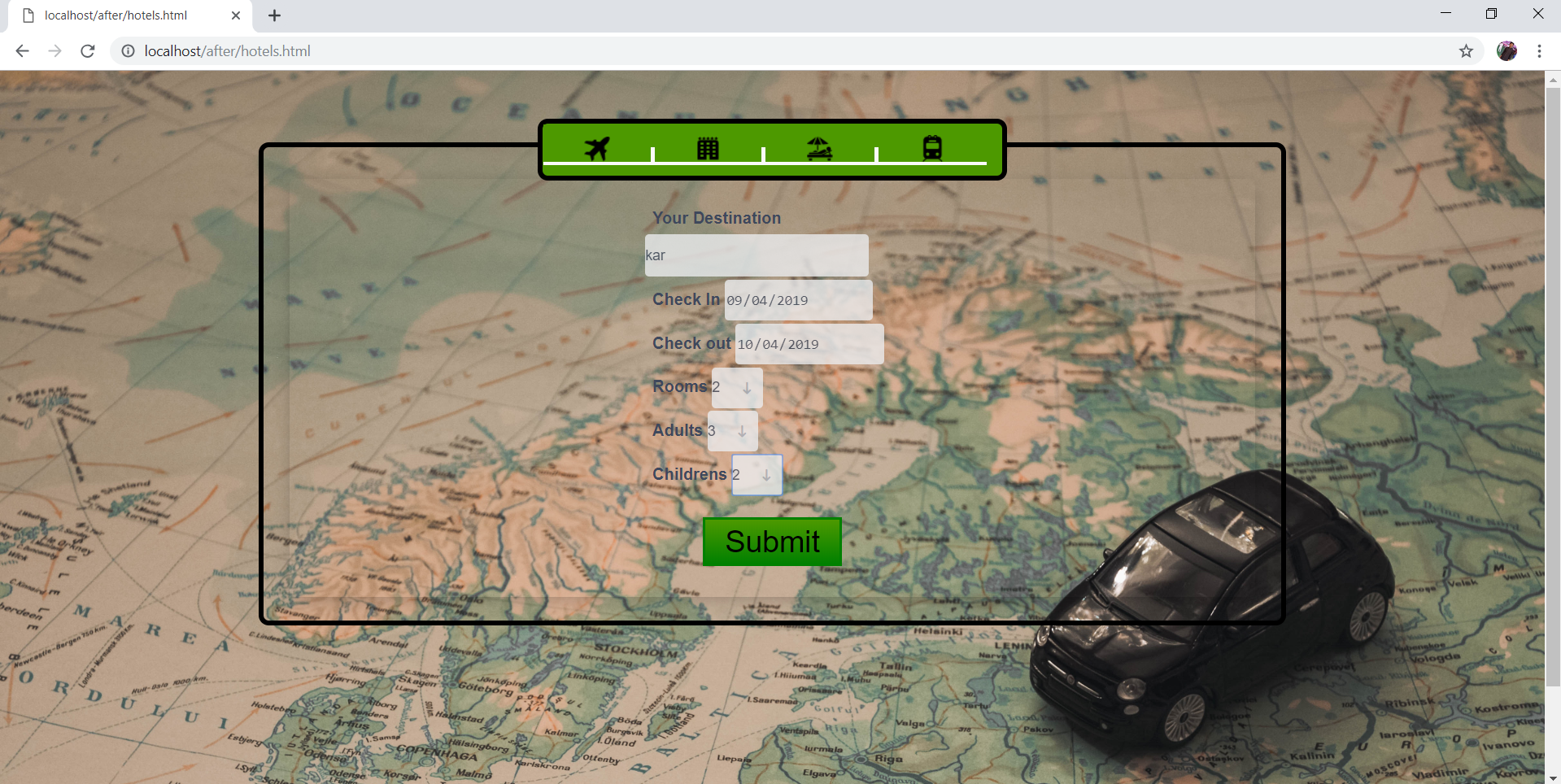TRAIN TIMMINS(TABLE):-

<html>

<body style="background: url(ddd.jpg); background-repeat: no-repeat; background-size: cover; background-position: center;">

<head>

<h1 style="font-size:70x; text-align:center">TIME TABLE</h1>

</head>

<hr>

<table style="width:100%" border=3>

<tr>

<th>TRAIN NUMBER</th>

<th>TRAIN NAME</th>

<th>TRAIN TYPE</th>

<th>RUN DAYS</th>

<th>DEPATURE TME(HRS)</th>

<th>ARRIVAL TIME(HRS)</th>

</tr>

<tr>

<td>12267</td>

<td>MUMBAI-AHMEDABAD</td>

<td><font color="blue" ><b>DURONTO</td>

<td>M,T,W,T,F,S,S</td>

<td>23:25</td>

<td>05:55</td>

</tr>

<tr>

<td>12268</td>

<td>KOLKATA SEALDAH - PURI DURONTO EXPRESS</td>

<td><font color="blue" ><b>DURONTO</td>

<td>M,W,F</td>

<td>22:00</td>

<td>04:00</td>

</tr>

<tr>

<td>22204</td>

<td>SECUNDERABAD - VISAKHAPATNAM AC DURONTO EXPRESS</td>

<td><font color="blue" ><b>DURONTO</td>

<td>M,W,S</td>

<td>20:15</td>

<td>20:15</td>

</tr>

<tr>

<td>22206</td>

<td>MADURAI - CHENNAI CENTRAL AC DURONTO EXPRESS</td>

<td><font color="blue" ><b>DURONTO</td>

<td>TUE,THU</td>

<td>22:40</td>

<td>22:40</td>

</tr>

<tr>

<td>11077</td>

<td>PUNE - JAMMU TAWI JHELUM EXPRESS</td>

<td><font color="blue" ><b>MAIL EXPRESS</td>

<td>M,T,W,T,F,S,S</td>

<td>17:20</td>

<td>10:10</td>

</tr>

<tr>

<td>2295</td>

<td>BANGALORE CITY - DANAPUR SANGHAMITRA SF EXP</td>

<td><font color="blue" ><b>SUPERFAST</td>

<td>M,T,W,T,F,S,S</td>

<td>09:00</td>

<td>09:20</td>

</tr>

<tr>

<td>12307</td>

<td>HOWRAH - JODHPUR SF EXPRESS</td>

<td><font color="blue" ><b>SUPERFAST</td>

<td>M,T,W,T,F,S,S</td>

<td>23:30</td>

<td>08:30</td>

</tr>

<tr>

<td>12801</td>

<td>PURI - NEW DELHI PURUSHOTTAM SF EXPRESS</td>

<td><font color="blue" ><b>SUPERFAST</td>

<td>M,T,W,T,F,S,S</td>

<td>21:45</td>

<td>04:50</td>

</tr>

</html>

`

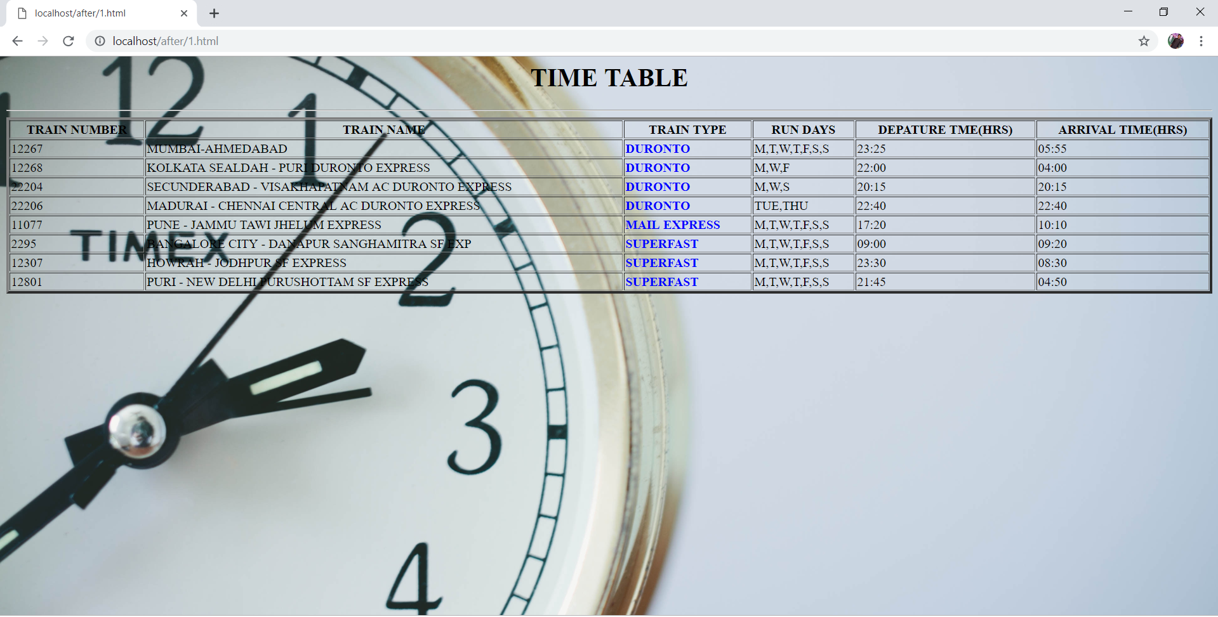MAP(LINK):-

HTML CODE:-

<!DOCTYPE html>

<html>

<head>

<title>Maps</title>

</head>

<body>

<iframe src="https://www.google.com/maps/embed?pb=!1m10!1m8!1m3!1d877607.1846175549!2d75.72984260534919!3d15.323743646086765!3m2!1i1024!2i768!4f13.1!5e0!3m2!1sen!2sin!4v1553847060243!5m2!1sen!2sin" width="600" height="450" frameborder="0" style="border:0" allowfullscreen></iframe>

</body>

</html>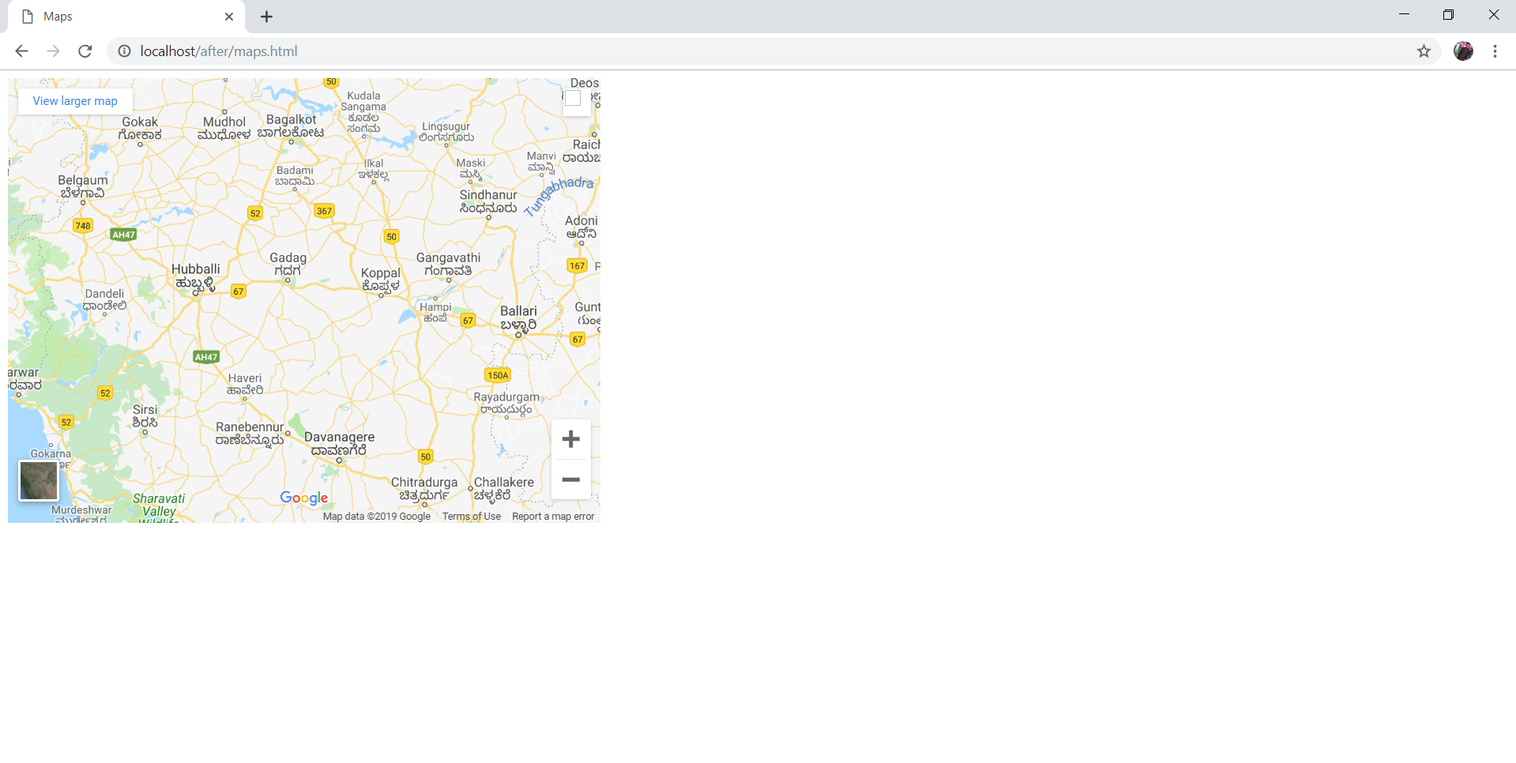

FILE UPLOADS:-

CODE:-

<html>

<head>

<link rel="stylesheet" type="text/css" href="css/style.css">

</head>

<body>

<ul>

<li><a href="">Home</a></li>

<li><a href="displaydata.php">E-Library</a></li>

<li><a href="" target="_blank">Visit My Blog!</a></li>

</ul>

<div class="form-style-6">

<h1>National E-Library </h1>

<form method="POST" action="connection.php" enctype="multipart/form-data" onsubmit="return validate(this)">

<input type="text" id="name" name="bookname" placeholder="Book Name*" required/>

<input type="text" name="bookdesc" placeholder="Book Description*" required/>

<input type="text" id="password" name="bookauthor" placeholder="Book Author*"/ required>

<select name="booklang" required>

<option selected disabled>Select Book Language*</option>

<option value="English">English</option>

<option value="Hindi">Hindi</option>

<option value="German">German</option>

<option value="French">French</option>

<option value="Other">Other Language</option>

</select>

<div style="padding-bottom: 6px"><label>Select Book* (Only Pdf, Doc & Docx files are allowed)</label></div>

<input type="file" name="bookfile" id="bookfile" required/>

<input type="text" id="name" name="uploadername" placeholder="Uploaders Name*" required/>

<input type="email" id="name" name="uploaderemail" placeholder="Uploaders Email*" required/>

<input type="submit" id="submit" name="submit">

</form>

</div>

</body>

</html>

<script>

function validate() {

var val = document.getElementById('bookfile').value.toLowerCase();

var regex = new RegExp("(.*?)\.(docx|doc|pdf)$");

if(!(regex.test(val))) {

document.getElementById('bookfile').value = '';

alert('Please select correct file format.');

return false;

}

return true;

}

</script>

CSS CODE:-

body {

background-image: url("../images/library.jpg");

background-repeat: no-repeat;

}

ul {

list-style-type: none;

margin: 0;

padding: 0;

overflow: hidden;

background-color: #43D1AF;

}

li {

float: left;

}

li a{

display: inline-block;

color: black;

font-weight: bold;

text-align: center;

padding: 14px 16px;

text-decoration: none;

}

li a:hover{

background-color: #6CC417;

}

.form-style-6{

font: 95% Arial, Helvetica, sans-serif;

max-width: 400px;

margin: 10px auto;

padding: 16px;

background: #F7F7F7;

}

.form-style-6 h1{

background: #43D1AF;

padding: 20px 0;

font-size: 140%;

font-weight: 300;

text-align: center;

color: #fff;

margin: -16px -16px 16px -16px;

}

.form-style-6 input[type="text"],

.form-style-6 input[type="email"],

.form-style-6 input[type="file"],

.form-style-6 textarea,

.form-style-6 select

{

-webkit-transition: all 0.30s ease-in-out;

-moz-transition: all 0.30s ease-in-out;

-ms-transition: all 0.30s ease-in-out;

-o-transition: all 0.30s ease-in-out;

outline: none;

box-sizing: border-box;

-webkit-box-sizing: border-box;

-moz-box-sizing: border-box;

width: 100%;

background: #fff;

margin-bottom: 4%;

border: 1px solid #ccc;

padding: 3%;

color: #555;

font: 95% Arial, Helvetica, sans-serif;

}

.form-style-6 input[type="text"]:focus,

.form-style-6 input[type="email"]:focus,

.form-style-6 input[type="file"]:focus,

.form-style-6 textarea:focus,

.form-style-6 select:focus

{

box-shadow: 0 0 5px #43D1AF;

padding: 3%;

border: 1px solid #43D1AF;

}

.form-style-6 input[type="submit"]{

box-sizing: border-box;

-webkit-box-sizing: border-box;

-moz-box-sizing: border-box;

width: 100%;

padding: 3%;

background: #43D1AF;

border-bottom: 2px solid #30C29E;

border-top-style: none;

border-right-style: none;

border-left-style: none;

color: #fff;

}

.form-style-6 input[type="submit"]:hover

background: #2EBC99;

}

PHP CODE:-

<?php

$servername="localhost";

$username="root";

$password="root";

$dbname="newdb";

// Create connection

$conn = new mysqli($servername, $username, $password, $dbname);

// Check connection

if ($conn->connect_error) {

die("Connection failed: " . $conn->connect_error);

}

//fetch from database

$sql = "SELECT * from bookdb";

$result = $conn->query($sql);

?>

<html>

</head>

<title>E-Library Display Section</title>

<link rel="stylesheet" type="text/css" href="css/display.css">

</head>

<body>

<ul>

<li><a href="index.html">Home</a></li>

<li><a href="">E-Library</a></li>

<li><a href="http://alapan.me" target="_blank">Visit My Blog!</a></li>

</ul>

<div style="overflow-x:auto;">

<h1>Books Available for Free Download</h1>

<table width="100%" cellspacing="0" cellpadding="18">

<div class="header">

<th>Book Name</th>

<th>Book Description</th>

<th>Book Author</th>

<th>Book Language</th>

<th>Download Link</th>

<th>Uploader Name</th>

<th>Uploader Email</th>

</div>

<tr>

<?php

while($row = $result->fetch_assoc()) {

echo "<tr>";

echo "<td>".$row['bookname']."</td>";

echo "<td>".$row['bookdesc']."</td>";

echo "<td>".$row['bookauthor']."</td>";

echo "<td>".$row['booklang']."</td>";

echo "<td><a href='http://localhost/E-Library-master/files/".$row['bookfile']."'><b>Download E-Book</b></a></td>";

echo "<td>".$row['uploadername']."</td>";

echo "<td>".$row['uploaderemail']."</td>";

echo "</tr>";

}

?>

</table>

</div>

</body>

</html>

